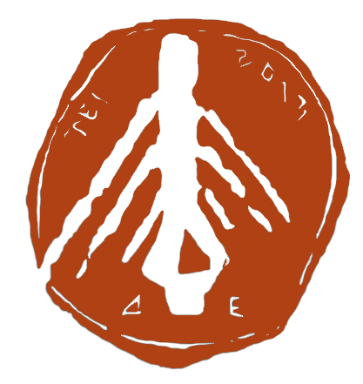
TECHNOLOGIKO EKPAIDEFTIKO IDRYMA

PHOTO
(TEI) DYTIKIS ELLADAS
-----------------------------------------------------------------
TECHNOLOGICAL EDUCATIONAL INSTITUTE
(TEI) OF WESTERN GREECE

ERASMUS+ APPLICATION FORM 2017 - 18
(INCOMING STUDENTS)

Deadlines: end of April for Winter Semester exchange
end of October for Spring Semester exchange

PERSONAL DETAILS:
First Name:
Family Name:
Sex: Male/Female |  | Age: |  | Date of Birth:
Nationality:
Current Address:

Contact Number (including country code):
Email address:
HOME INSTITUTION:
Current Course of Study:
Length of Course: |  |  | Year of Study:

My spoken Greek is:  My spoken English is | Poor  Poor | Fair:  Fair: | Good  Good | Fluent  Fluent
I hold the following language qualifications:

EXCHANGE DETAILS: (Please tick the appropriate box)

MOBILITY FOR STUDIES

MOBILITY FOR TRAINEESHIPS
Course Requested: (Please tick the appropriate box)
Accounting (Patra)
Accounting and Finance (Mesolonghi)
Business Administration (Patra)
Business Administration (Mesolonghi)
Management, Economy, and Communication of Cultural and Touristic Institutions (Pyrgos)
Informatics and Means of Mass Communication (Pyrgos)
Tourism Business (Patra)
Mechanical Engineering (Patra)
Renewable Energy Systems (RES) - Msc Program
Electrical Engineering (Patra)
Civil Engineering (Patra)
Computer & Informatics Engineering (Antirio)
Technologies and Infrastructures for Broadband Applications and Services - Msc Program
Nursing (Patra)
Physiotherapy (Aigio)
Speech and Language Therapy (Patra)
Optics and Optometry (Aigio)
Social Work (Patra)
Fisheries and Aquaculture Technology (Mesolonghi)
Mechanical and Water Resources Engineering (Mesolonghi)
Agricultural Technology (Amaliada)
Dates requested: (Please tick the appropriate box)
Winter Semester: 1st October 2017 – 10th January 2018
Spring Semester: 1st February 2018 – 30th June 2018
Alternative (may or may not be possible):

Credits required:
ECTS:
TEI OF WESTERN GREECE:
During my exchange I wish to achieve the following:

I have Expertise/sound knowledge in the following:

Please attach:
Nomination Letter from your home institution
Learning agreement
Passport or ID
European Health Insurance Card (EHIC)
Please return by: end of June for Winter Semester exchange
end of October for Spring Semester exchange

Please return to: | TEI of Western Greece  Department of Public and International Relations  cc. Giagkos Inglesis  Megalou Alexandrou 1,  26334 Koukouli, Patra  Greece  Telephone: +30 2610 314170  Email: Intoffice@teiwest.gr

Sent by: | Name: Signature:
 | Tel. email:

